**Update Plans for NMR MagBody**

**Tray slot:**

This was the hardest hole to machine/cut out because it had to go through the entire part where it is 4.04 in. high. This process involved drilling out the frame of the hole and then removing the rest of the material using the end mill. The largest tool that could be used to do this on the mill was a 1/2 x 2 in. end mill.

The first half of the hole had to be machined out on one side and then flipped and repeated. Even after going as deep as the tool allowed on both sides, there was still material left in the middle of the part. This excess material was removed by plunging the tool deeper and slightly off the wall of the hole so as to only used the bottom face of the end mill to cut and not the sides. Once this material was removed, a clean edge could not be achieved because the end mill was not long enough to clean all edges of the inside of the whole. These rough edges had to be filed out manually.

Improvements:

1. If the part could be smaller than 4 in. on all sides, all machining operations would be much simpler and easier.
2. If the tray hole could be machined out using a “rectangle pocket” function on a CNC, it would speed up the process significantly and also eliminate any user error of going too far one way or another while the tool is in the part.
3. Cutting the hole out from only one side - Whenever the part has to be flipped on the table to be cut out from the other side, the measurements do not always line up the same as they did on the other side and the holes can be slightly off center.

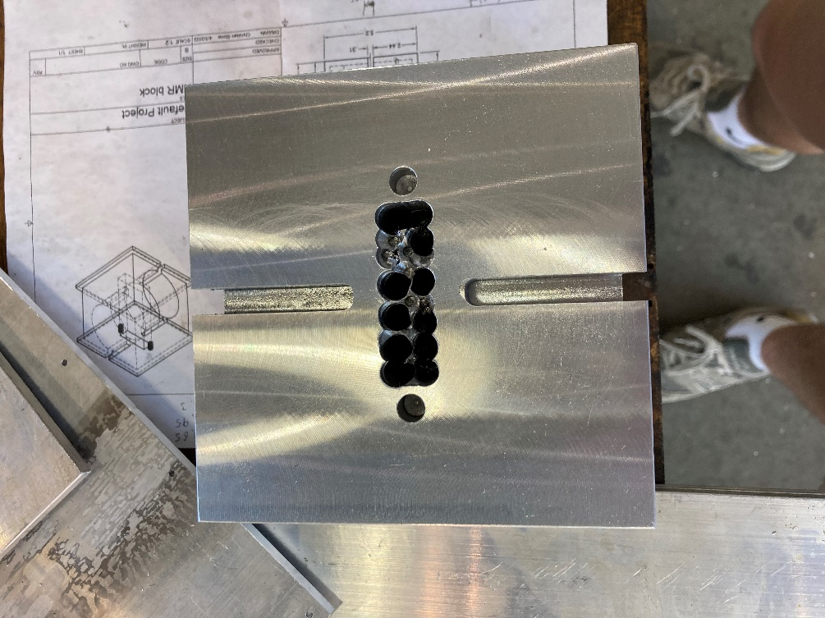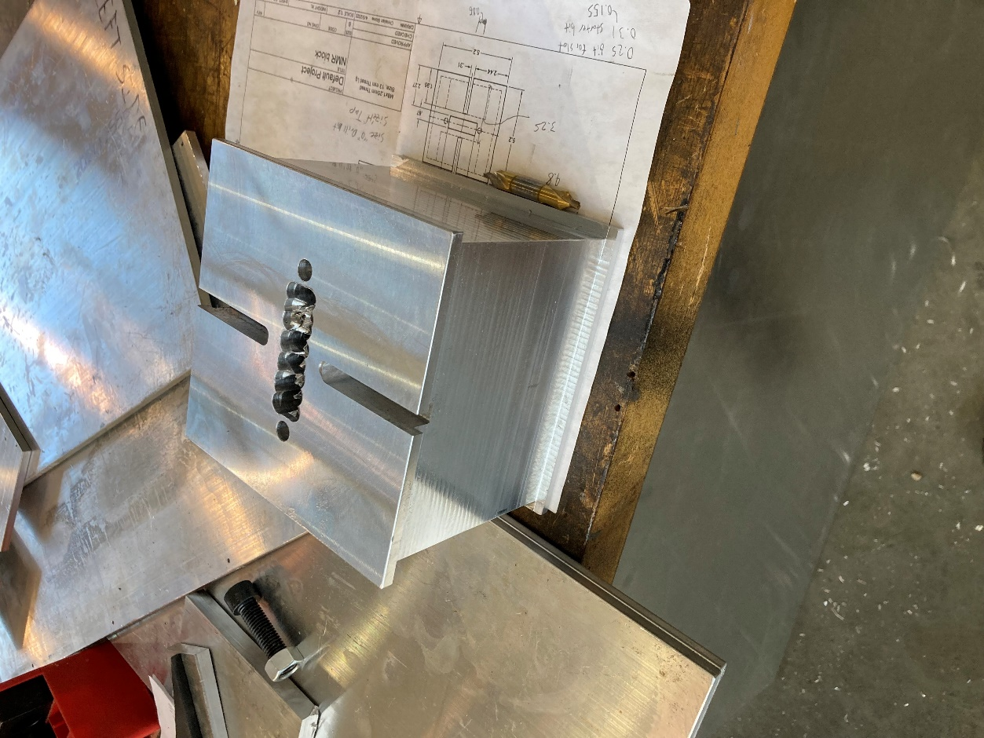

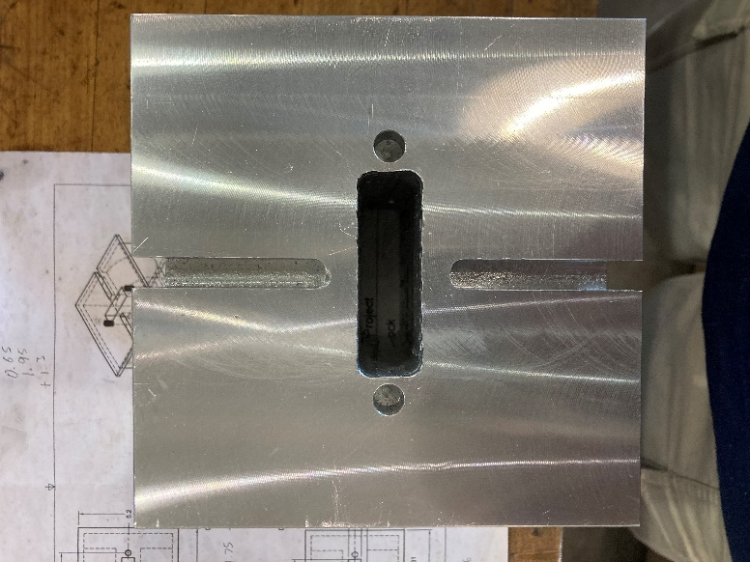

**Steel bar slots:**

These slots were machined out using the same end mill as before. The slots were cut by going back and forth manually and then flipping the part around to cut all four sides.

Improvements:

1. Use a rectangle pocket function from the center of the part as deep as the groove needs to be cut. This would speed up the process and eliminate user error.

**Magnet slots:**

The magnet slots have to be cut out using the large CNC machine because of the size and the dept of the cut.

All other machining operations on this part were fairly simple and straight forward. The bolt holes can be threaded manually.

